Chlorhexidine Decolonization for Patients1,2

A hand holding a magnifying glass with bacteria

 Bacteria in your skin, wounds, or your gut can infect your IV line. These germs are microscopic and invisible to the naked eye. Bacteria can spread by skin-to-skin contact between people, breaks in the skin such as cuts or scrapes, touching dirty items, being in crowds, and poor hygiene. Bacteria can also spread if you touch objects that has touched someone else’s skin. Bacteria often live in wounds, so keep your wounds covered with bandages. This guide will help you clean your skin of bacteria that could infect your IV line.

A person washing their hands under a running water faucet
 Good hygiene, especially regular hand washing and regular bathing, is the best way to prevent an IV line infection. Soap and water, as well as alcohol-based hand sanitizers, kill bacteria. Keep your hands clean by washing regularly with soap and water or a hand sanitizer. Take showers or baths with soap.

If your hands look dirty or you’ve just used the bathroom, you must use soap and water. Wash your hands with soap and water for at least 20 seconds. Sing the “Happy Birthday” song twice to help you wash your hands for 20 seconds. Use your own clean hand towel to dry your hands, or use paper towels.

A person using a hand sanitizer

 If your hands do not look dirty, and you have not just used the bathroom, you can use soap and water or hand sanitizer. Hand sanitizers should have at least 60% alcohol. Use enough to cover every part of your hands. Apply hand sanitizer to every part of your hands and rub together, getting between the fingers and thumb, and around the nails. Continue to rub your hands together until dry, about 20 seconds. Allow your hands to air dry. Do not wipe or shake your hands.

An icon of hands washing
 

Always wash your hands:

* Before preparing food, eating, or drinking.
* After coughing, sneezing, or blowing your nose.
* Before and after touching your eyes, nose, mouth, or genitals.
* Before and after touching any cuts or wounds, including sores, acne, boils, or rashes.
* Before and after changing bandages.
* After going to the bathroom.
* After touching urine, feces (poop), and body fluids. This includes items soiled with body fluids, such as bedding or clothes.
* After cleaning the bathroom, changing your bedding, and doing laundry.
* After touching things other people touch, such as door knobs, shopping carts, gym or rehab equipment.

**Cleaning Surfaces and Personal Items**

A person cleaning a table
 Cleaning shared surfaces is important. If you share medical equipment or gym equipment, disinfect the equipment before and after you use it. Do not share towels, washcloths, razors, or other personal items. Clean bathrooms and countertops daily with household cleaners such as disinfectants or bleach. Look for something with the word “disinfectant” or “bleach.”1 Follow the directions on the disinfectant’s label. Focus on surfaces that people touch every day, such as light switches, doorknobs, phones, toilets, sinks, and kitchen counters. Wipe with a disinfectant wipe, spray the surface with a disinfectant and let it dry, or spray the surface with a disinfectant and spread the disinfectant with a paper towel. You do not need to focus on large surfaces such as floors and walls.

A person putting clothes into a washing machine
 Wash your sheets, washcloths, and towels at least once a week. Change your clothes daily and wash them before wearing again. Keep clean and dirty laundry separate. Hold dirty laundry away from yourself to prevent bacteria from getting on your clothes. If the laundry has bodily fluids on them, wash them immediately, or place them into a plastic bag until they can be washed. Wash everything in water as hot as the fabric allows. Use color-safe bleach if your clothes allow it, but laundry detergent also works well to kill bacteria. Dry all laundry in a hot dryer and make sure laundry is completely dry before folding it.

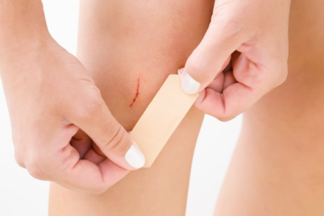**Caring for Wounds**

If you get a cut or scrape, clean it with soap and water and cover it with a bandage until it heals. Keep any infected wounds covered with a bandage. Clean your hands immediately after putting on or changing bandages. Wear clothes that keep bandages and wounds covered. Do not touch wounds. If you do touch a wound, wash your hands right away. Those helping to care for you and those in your household should also wash their hands frequently, especially when changing bandages or touching a wound. Bathe immediately after physical therapy sessions or exercise.

**Reducing the Bacteria on your Body**

You will use three different soaps and medicines to reduce the bacteria on your body. These three soaps and medicines are commonly used in hospitals to reduce bacteria on patients.

1. 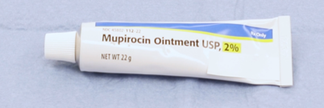Mupirocin ointment reduces the bacteria in your nose.
2. 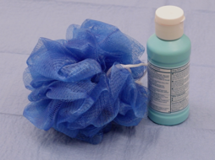Chlorhexidine soap reduces the bacteria on your skin.
3. A close-up of a person pouring blue liquid into a small container

   Description automatically generatedChlorhexidine mouthwash reduces the  
      
   bacteria in your mouth.

Do not use these products if you are allergic to them. Do not get chlorhexidine in your eyes or ear canals. If chlorhexidine does get into your eyes, flush with water.

*Every other week*, do the following steps for five days in a row; for example, Monday through Friday:

* Daily bathing with chlorhexidine soap
* Twice daily rinsing with chlorhexidine mouthwash
* Twice daily mupirocin to the nose

If you forget to shower or bathe with chlorhexidine for a single day, restart the chlorhexidine protocol as soon as possible until you have used all three steps for a total of 5 days, not counting the skipped day. If you skip more than one day’s worth of chlorhexidine bathing, restart the 5 days of therapy with all three treatments.

Chlorhexidine soap:

You will use chlorhexidine soap in the shower *instead* of regular soap and shampoo. Other soaps, shampoos, lotions, or sunscreens can make chlorhexidine less effective. In the five day period when you are using chlorhexidine, do not use other soaps or shampoos with the exception of hand soap. You can use hair conditioner, shaving cream, deodorant, hair gel, and hair wax. Many lotions also make chlorhexidine less effective. If you want to use lotion, use Cetaphil Moisturizing Lotion or Eucerin Original Lotion. Do not use perfume or cologne. Sunscreen can also inactivate chlorhexidine, so do your best to avoid suntan lotion and sunscreen in the five day period when you are using chlorhexidine. Instead, avoid the sun, and cover up with long sleeves, pants, and hats.

A group of brown spots on a white cloth
 Chlorhexidine is safe on rashes and bruises. It is also safe to use on small shallow wounds. Chlorhexidine is safe to use on surgical incisions including staples or stitches. Do not use chlorhexidine on deep open wounds.

Do not put the chlorhexidine directly on surfaces or linens that you will wash with bleach, as a brown stain will appear if chlorhexidine contacts bleach.

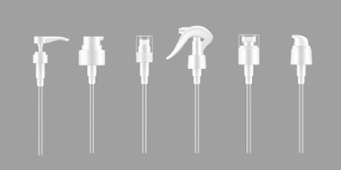

If you develop a rash or skin irritation, stop using the chlorhexidine and contact your medical provider.

***Use chlorhexidine soap that has a pump. Use a clean washcloth every time you use chlorhexidine***.

1. Wet your face and hair with water.
2. With your head and hair out of the water stream, pump chlorhexidine onto your hands and massage it onto your face, hair, and scalp. Avoid your eyes and ears.
3. Rinse your face and hair with water.
4. If you want, you can use hair conditioner at this point.
5. Wet the washcloth.
6. Use three pumps of chlorhexidine on the wet washcloth and rub it into a lather.
7. Turn off the shower water. Chlorhexidine needs to be on your body for two minutes to kill bacteria.
8. 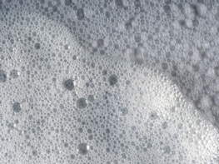Firmly massage the soapy chlorhexidine onto your skin. Get soap between all skin folds.
   * Start with your IV line. Clean the skin around the IV line. Wipe the outside of the IV line and the hub with chlorhexidine.
   * Wash your neck.
   * Wash your arms and legs one at a time.
   * Then wash your chest and back. Women should wash under the breasts.
   * Then wash your abdomen.
   * Then apply chlorhexidine to your hip and groin.
   * A black and white logo

     Description automatically generatedFinally, wash your genitals and buttocks. Only use chlorhexidine on external genital areas.
9. At this point, turn on a two-minute timer.
10. Reapply the chlorhexidine just as you did before.
11. Once the two-minute timer goes off, turn on the water.
12. 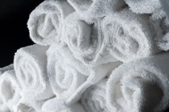Rinse and pat dry with a clean towel.

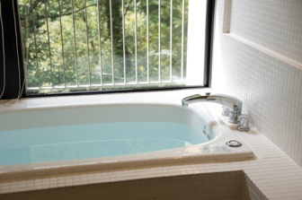If you are using chlorhexidine in a bath, follow the above instructions. Instead of turning off the water and turning it back on, move each body part out of the water in the bath to rub the chlorhexidine into the skin and keep the body part out of the water for two minutes prior to rinsing.

Chlorhexidine Mouthwash

Chlorhexidine mouthwash reduces the amount of bacteria in the throat, gums, and teeth. During the same five-day period as the chlorhexidine bathing, use chlorhexidine mouthwash twice a day. Do not swallow the chlorhexidine mouthwash, but if you accidentally swallow a small amount, this is considered safe. There is a small amount of alcohol in the chlorhexidine mouthwash. Keep the bottle away from children.

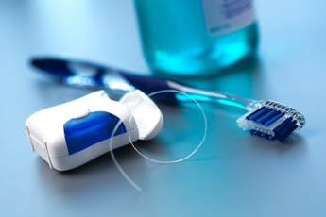Chlorhexidine mouthwash may stain your teeth. Be sure to brush and floss your teeth right before you use the chlorhexidine mouthwash. Do not use other mouthwashes. Rinse your mouth completely with water before using the chlorhexidine because toothpaste can make the chlorhexidine less effective. Do not eat or drink for at least an hour after using the chlorhexidine mouthwash. If you notice that foods taste differently, wait a few hours before eating. You should get used to the taste over time.

If you forget one day’s worth of chlorhexidine mouthwash, perform mouth washing with chlorhexidine mouthwash as soon as possible and get back on your regular schedule. If you skip more than one day’s worth of mouth washing, you will need to restart the five days of therapy with all treatments (chlorhexidine bath, chlorhexidine mouthwash, and mupirocin ointment).

If you develop mouth irritation, stop using the chlorhexidine mouthwash and contact your medical provider.

To use chlorhexidine mouthwash:

* 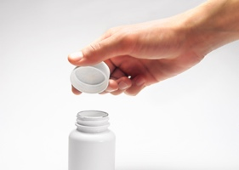Use the cap on the container to measure 15 mL (1/2 ounce) of chlorhexidine.
* Swish the chlorhexidine in your mouth for 30 seconds.
* Spit out the chlorhexidine.
* 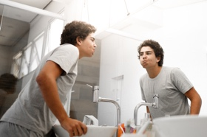Do not rinse out your mouth after using the chlorhexidine.
* Use this in the morning and evening.

Mupirocin Nasal Ointment

During the same 5-day period as when you are bathing with chlorhexidine, use mupirocin nose ointment twice a day. Do not get it in your eyes.

If you forget one day’s worth of mupirocin nasal ointment, use the mupirocin nasal ointment as soon as possible and get back on your regular schedule. If you skip more than one day’s worth of mupirocin ointment, you will need to restart the five days of therapy with all treatments (chlorhexidine bath, chlorhexidine mouthwash, and mupirocin ointment).

A person blowing her nose

 Ask your doctor about using other medicines inside the nose or nasal sprays on the same days that you are using the mupirocin ointment. Other nose medications may make the mupirocin less effective.

Use the mupirocin ointment even if you have a stuffy or runny nose. If you do, use the ointment after blowing your nose. If you need to blow your nose, wait five minutes after the ointment to blow your nose.

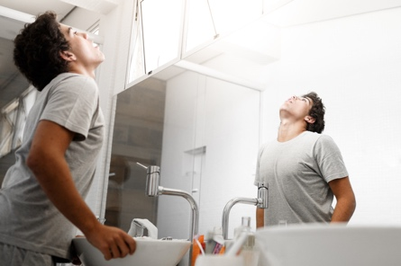To use mupirocin nasal ointment:

1. Tilt your head back.
2. Turn the cap counterclockwise to puncture the seal.
3. Apply half the tube content into each nostril.
4. Use a cotton swab to spread the ointment.
5. Press nostrils together and massage for one minute.
6. Wash your hands with soap and water.

If you experience irritation, stop using the mupirocin and contact your medical provider. If the ointment makes you sneeze, try using the ointment more gently.

**REFERENCE**

1. *Huang SS, Septimus E, Kleinman K, et al. Chlorhexidine versus routine bathing to prevent multidrug-resistant organisms and all-cause bloodstream infections in general medical and surgical units (ABATE Infection trial): a cluster-randomised trial. Lancet. 2019;393(10177):1205-1215. doi:10.1016/S0140-6736(18)32593-5*

Huang SS, Singh R, McKinnell JA, et al. Decolonization to Reduce Postdischarge Infection Risk among MRSA Carriers. New England Journal of Medicine. 2019;380(7):638-650. doi:10.1056/NEJMoa1716771